ACE sediment trap field day – key stops and diagrams. For more information please contact ACE or Environment Southland
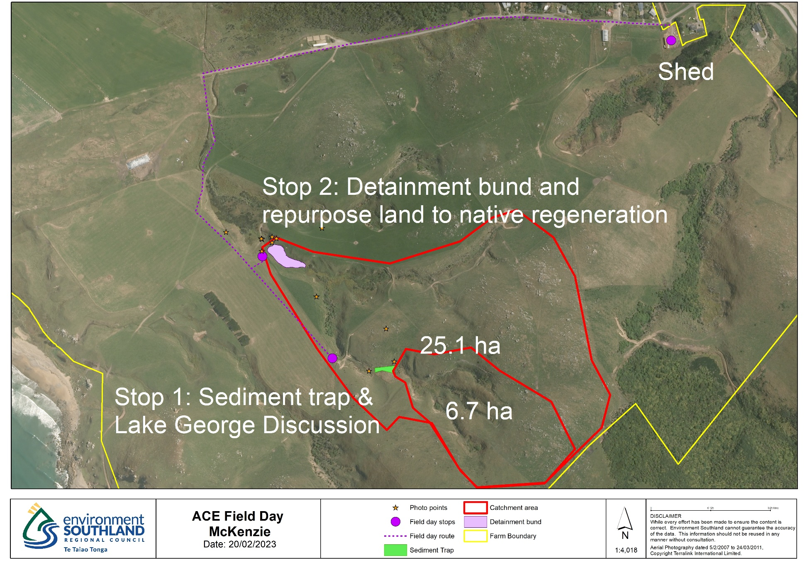
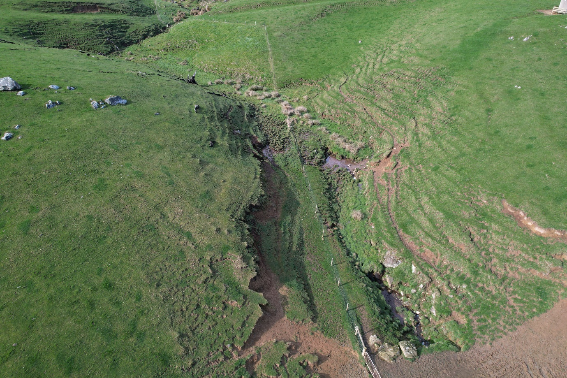
Figure 1: Stop 1 to look at a potential site for a sediment trap that will treat around 6.7 hectares. 40m2 x 6.7 (ha) is 268 m2. A 35 metre long by 8 metre wide sediment trap will cover a 280 m2 area.
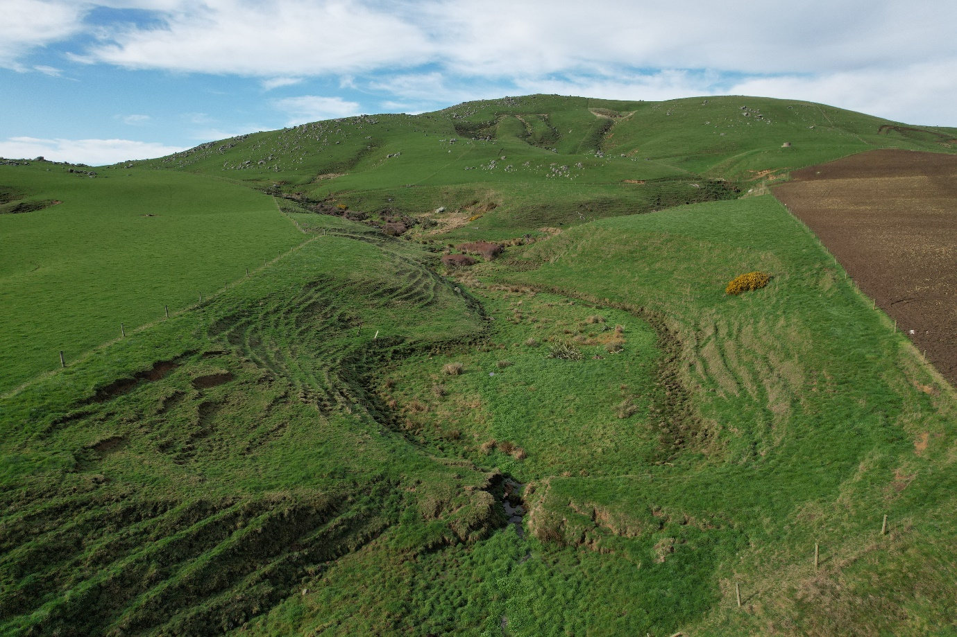
Figure 2: Stop 2 looking up the gully to be repurposed into native regeneration. Thick grasses and shrubs will help capture sediment and slow runoff. Lower area in the foreground has the potential to be used as a detainment area behind a bund.
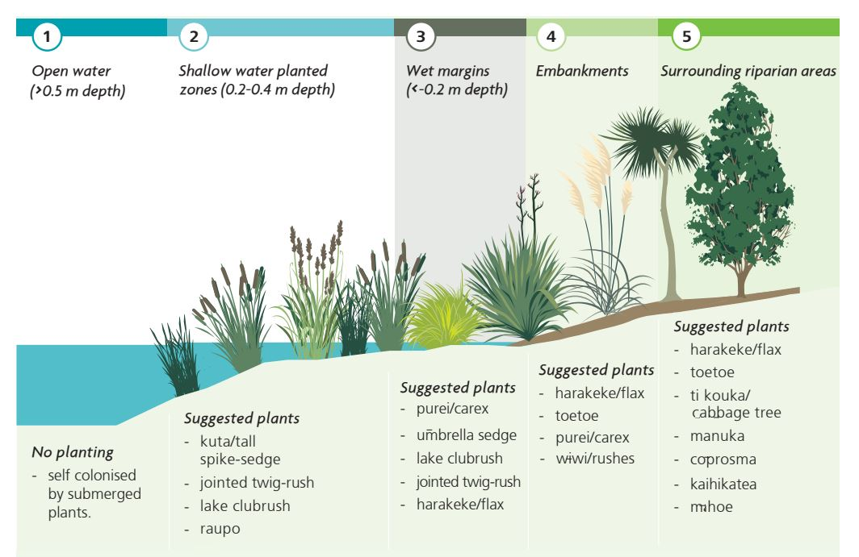
Figure 3: Planting recommendations from NIWA Constructed Wetland Guidelines

Detainment bund^{PS120©}: A guideline for on-farm, pasture based, storm water run-off treatment by John H Paterson, Dylan T. Clarke and Brian Levine, 200518 V13. Produced by The phosphorus Mitigation Project Inc.
*Correspondence to: john.patersonPMP@gmail.com
Copyright © 2019 Phosphorus Mitigation Project Inc. All Rights Reserved. 200518 V13

Page 23 detainment bund Guide: “For each viable DB site, the ‘mock-up’ drawn by your GIS professional will effectively constitute a ‘plan view’ scale drawing with”:
• The catchment size (in ha)
• The length and height footprint of the bund’s earthworks (m),
• The ponding extent and its measured area (m²),
• The DB volume (m³),
• The specific storage to catchment ratio calculation (optimal is ≥120:1),
• ‘Run’ Distance - The longest water run path (m) from the top of catchment to the DB,
• ‘Rise’ - The change in elevation (m) from the DB site to the highest point in the catchment, and
• Rise/Run x 100 = % Slope.
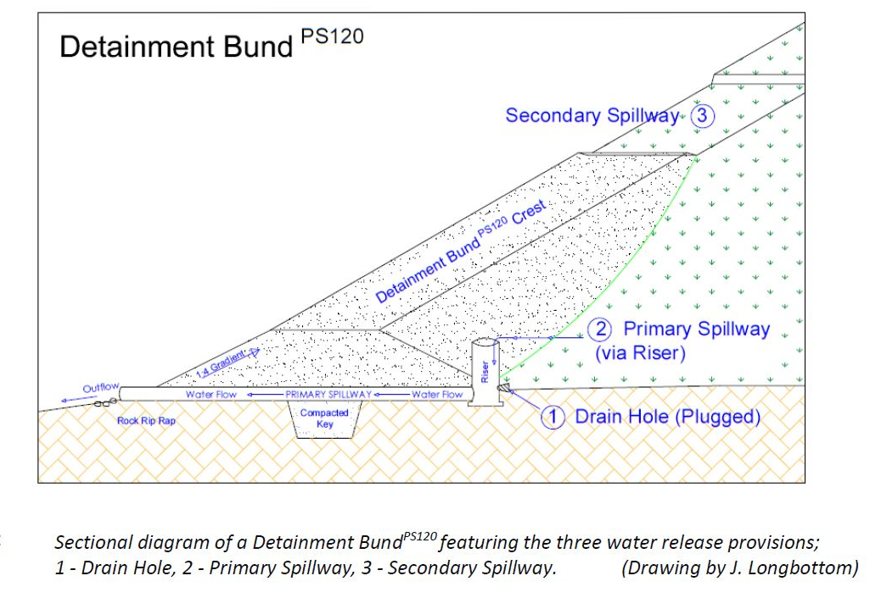
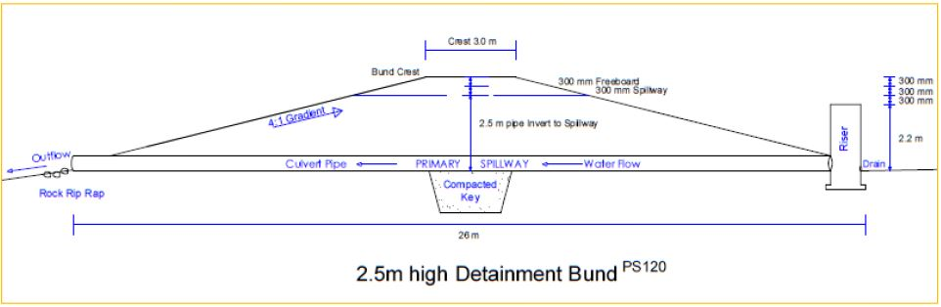
Figure 4: Cross sectional diagram of a detainment bund (Paterson et al, 2019 pg 25)
Page 25, Detainment bund resource
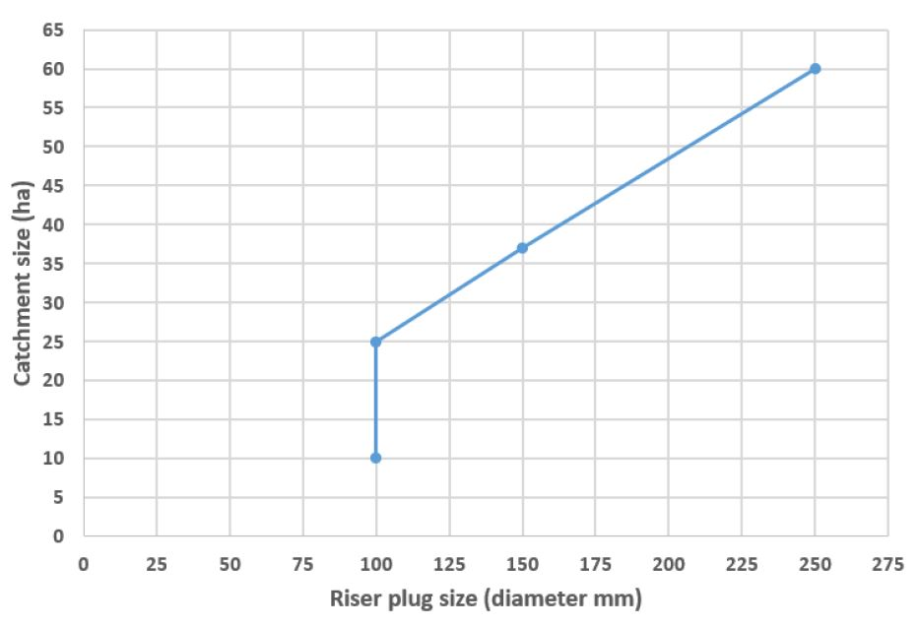
Figure 5: Culvert diametre to go through bund wall.

